Press release ifm-pm 857/0226 Area: Company news

New CTO at ifm
Essen, 5 May 2026 – As of 1 May 2026, changes have been made to the senior management of the ifm group. The former CTO, Benno Kathan, who spent almost 35 successful years at ifm, took his well-deserved retirement at the end of April. In this context, his responsibilities of the technical management departments of the business units ifm process group, ifm solutions and ifm network & control group will be reassigned. Dr Volker Frey (CTO), who was previously CEO of the business unit ifm position group and a member of the Executive Board, has been Executive Director and successor to Benno Kathan since 1 May. In the future, he will be responsible for the overall technical management of sensor technology at ifm. This will include not only the business unit ifm position group, but also the business unit ifm process group. Martin Buck (co-CEO) will take over the technical management of ifm solutions in addition to his role as head of the business unit ifm network & control group.

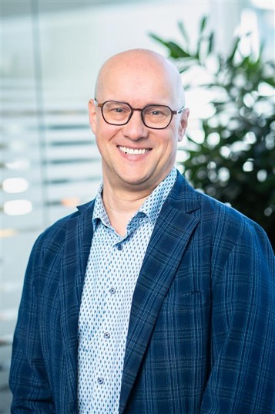 | ifm-pm 857 print.jpg  Dr Volker Frey (CTO) has been Executive Director since 1 May, succeeding Benno Kathan, who is taking his well-deserved retirement.

About the ifm group of companies
From a passion, to an idea, to success. Since its foundation in 1969, ifm has developed, produced and sold sensors, controllers, software and systems for industrial automation and for SAP-based solutions for supply chain management and shop floor integration worldwide. As one of the pioneers of Industry 4.0, ifm develops and implements consistent solutions to digitalise the entire value chain “from sensor to ERP”. Today, the second-generation family-run ifm group has more than 9,120 employees, including more than 5,260 in Germany, and is one of the worldwide market leaders. The group combines the internationality and innovative strength of a growing group of companies with the flexibility and close customer contact of a medium-sized company.

Printing free of charge – reference copy requested.

Editorial enquiries  Agentur Dr. Lantzsch  Jörg Lantzsch  Müllerstr. 5  65183 Wiesbaden  www.drlantzsch.de  Tel.: +49 611 205 93 71  Email: info@drlantzsch.de | Contact  ifm electronic gmbh  Simone Felderhoff  Friedrichstr. 1  45128 Essen  www.ifm.com  Tel.: +49 201 24 22 0  Fax: +49 201 24 22 1200  Email: presse@ifm.com

